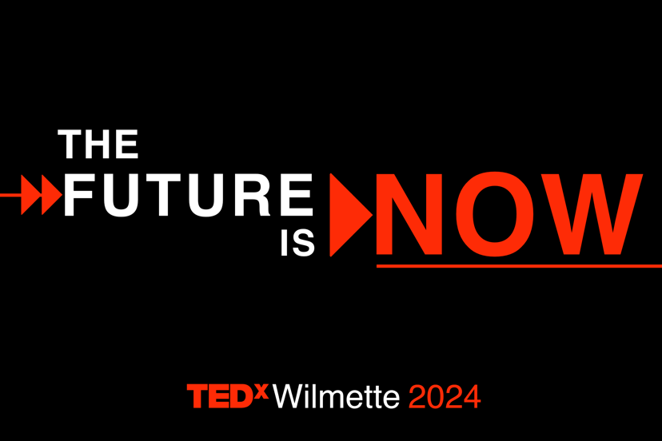

TEDxWilmette 2024 Speaker Application

At TEDxWilmette, we bring together strong and creative women who consciously elevate ideas that support the greater good of our communities and the world. Connecting women to each other, to their communities, and to big ideas is our fundamental mission.

TEDxWilmette reveals our 2024 theme: The Future Is Now

The pace of change in our world brings what once felt futuristic into the present. From climate to AI, media to healthcare, we face big technological, ethical and social questions, and the answers have implications not only for our shared future but also for our common present. At TEDxWilmette 2024, we will explore how to navigate these issues when The Future Is Now.

Six inspiring women will unleash the incredible potential of our new reality while opening our minds and imaginations to the choices we still have surrounding these advancements. Six persuasive talks will help us pause to contemplate our evolution and bravely and boldly ensure the best outcome now and for future generations.

The TEDxWilmette 2024 event will consist of six live 7-9 minute talks on Saturday, April 20, 2024. In addition, speakers will participate in one Salon event held in Wilmette on a mutually convenient date throughout 2024 and early 2025, which includes a showing of the talk video followed by a facilitated Q&A.

We are looking for:

- A new or surprising idea - this might challenge a common belief, or offer a new angle to consider on an existing idea under the umbrella of this year’s theme. The idea should be delivered with observations, factual analysis, and conclusions. While the idea is not a story, it does require personality and vulnerability to connect with the audience in a compelling, thought-provoking and innovative way. For more information, see: What Makes a Great TED Talk?
- An individual with the charisma to engage our community in a live 7 to 9 minute talk as well as through possible online interaction.

Applicants MUST live in the greater Chicagoland area.

This form must be submitted via email to TEDxWilmetteSpeakers@gmail.com by 11:59 pm on Friday, October 20, 2023. If you are chosen to be a speaker, our team will provide you with the tools necessary for success. We cannot wait to hear your idea! *

*Please note that this Speaker Application is best viewed and completed via computer.

Name: Click or tap here to enter text.

Email address: Click or tap here to enter text.

Phone number: Click or tap here to enter text.

Mailing address:* Click or tap here to enter text.

*Because this is a community-based event, we will only consider applications from women who reside in the Chicagoland area.

Tell us about your idea and what inspired it. (250-500 words)

Click or tap here to enter text.

Click or tap here to enter text.

How does your idea embrace the theme: THE FUTURE IS NOW?

Click or tap here to enter text.

In fifteen words or less, please explain the takeaway message from your talk.

Click or tap here to enter text.

What is your “call to action” for our audience?

Click or tap here to enter text.

Have you shared this idea in other formats or with other audiences? If so, please describe.

Click or tap here to enter text.

Please provide your social media handles: Facebook, LinkedIn, Instagram, Twitter. If applicable, please also provide your website URL.

Click or tap here to enter text.

OPTIONAL RESUME: If you would like to provide a resume, please email it to TEDxWilmetteSpeakers@gmail.com.

Speakers will be allotted 7-9 minutes for their talks. Speakers may choose to show 1-3 slides (unless the idea is communicated via performance). What would you envision sharing on your slides?

Click or tap here to enter text.

Please send a one-minute video describing yourself and your THE FUTURE IS NOW idea to TEDxWilmetteSpeakers@gmail.com.

SPEAKER COMMITMENT

Our TEDxWilmette 2024 team makes a serious investment in each speaker and, as a result, being a speaker at our event is a serious commitment. As a speaker, you will be asked to do the following:

Be familiar with the TEDx talk rules, including but not limited to: Speakers may not sell or self-promote their product or business; speakers may not be compensated; talks may not be political or religious in nature. See: TEDx Content Guidelines

Commit to this schedule of dates and deliverables:

- Oct 20, 2023 – Application submission deadline.
- Nov 3, 2023 – Selected speakers will be notified.
- Nov 9, 2023 – Attend an Orientation Meeting at 7 pm CST (in person in Wilmette). Speaker coaches will be introduced.
- Nov 9, 2023 – Provide a short biography and a high-resolution photo to the Speaker Development Team (SDT).
- Nov 27, 2023 – Submit a strong outline of your talk to the SDT.
- Nov 30, 2023 – Participate in a Speaker Workshop, 7 - 8:30 pm CST (in person in Wilmette).
- Jan 12, 2024 – Deliver a draft script to the SDT for review.
- Jan 19, 2024 – Receive feedback on script and work to refine content and delivery.
- Feb 10 or 11, 2024 – Give virtual talk to the SDT.
- Feb 15, 2024 – Receive feedback on talk.
- March 4, 2024 – Revise talk and have slides completed.
- March 16 or 17, 2024 – Present talk virtually to the SDT without notes.
- Apr. 19, 2024 Dress rehearsal; give entire talk.
- Apr. 20, 2024 (times TBA) – EVENT DAY – Please reserve the entire day and evening. Call time will be approx. one hour earlier than the event start time. The after party will occur at a separate location following the event.
- Post event – Participate in one Salon on a mutually convenient date. Salons are held in Wilmette, typically on a Tuesday evening from 7:15 - 8:30 pm, and include a showing of your talk video followed by a facilitated Q&A.

Respond to correspondence from the TEDxWilmette 2024 team in a timely manner.

☐ As a speaker, I understand the commitment I am making and agree to the expectations outlined above. (Please check the box to agree.)

TEDxWilmette 2024 TEAM COMMITMENT

Our TEDxWilmette 2024 team commits to the following:

- Supporting you during your talk creation and editing process.
- Providing you with a speaker coach that will work with you one-on-one.
- Communicating with you regularly and in a timely manner about expectations and timeline.
- Acting as a resource for your questions, problem-solving, troubleshooting, etc.
- Assisting you with any technical issues.
- Promoting your idea and talk leading up to and after the event.
- Connecting you with community leaders and members.
- Being your biggest cheerleaders and supporters throughout the process and on the day of the event!

While we receive a large number of qualified applications, we are unfortunately limited to selecting six speakers. All applicants will be notified by Friday, November 3, 2023 regarding the results of their application.

Please email your application to TEDxWilmetteSpeakers@gmail.com. Please note that both the written and video portions must be completed and submitted before an application may be considered.

If you have any questions, please contact us at TEDxWilmetteSpeakers@gmail.com.

Thank you for applying!

